**CREATING BIT BUCKET BRANCH AND CREATING PULL REQUEST**

1. Create a branch from "develop" branch
2. NOTE: This must be done for each affected repository
3. Implement the change
4. If applicable, create unit tests
5. Test it locally, make sure the improvement works
6. Push the branch to Bitbucket
7. Create pull request ("feature/MCC-4321" -> "develop")

NOTE: Do it for each affected repository

1. Request team member to review and approve
2. Merge the PR (pipeline to rebuild the app on the DEV environment is launched automatically)
3. Check changes on the DEV environment

**Naming convention for branches**

* For features: feature/<ticket number>, i.e. “feature/MCC-5432”
* For bug fixes: bugfix/<ticket number>, i.e. “bugfix/MCC-4321”

STEP 1: Goto the appropriate bitbucket repository where you have to perform the code update.

STEP 2: Click on Branch

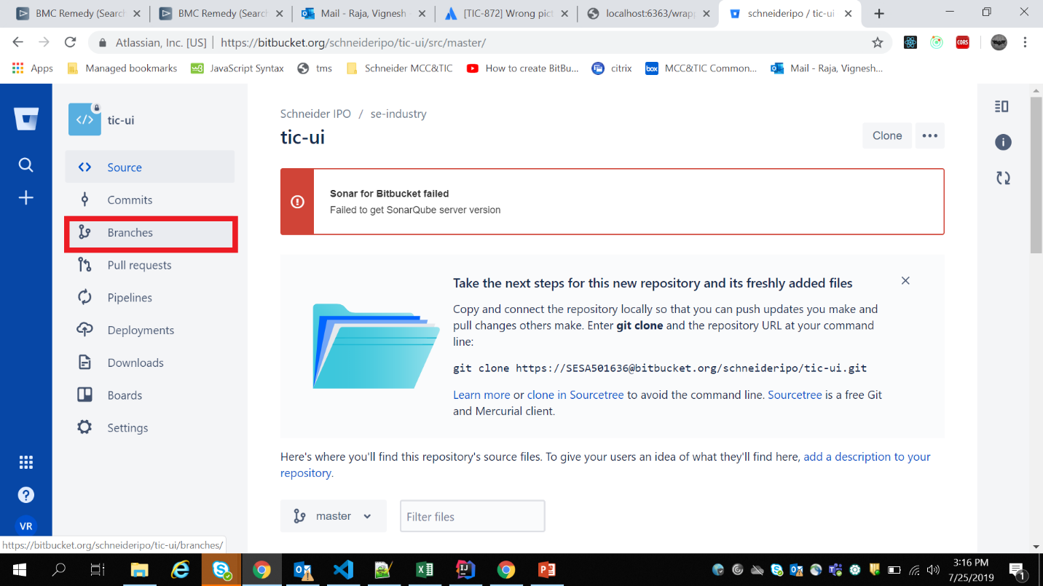

STEP 3: Click on Create Branch

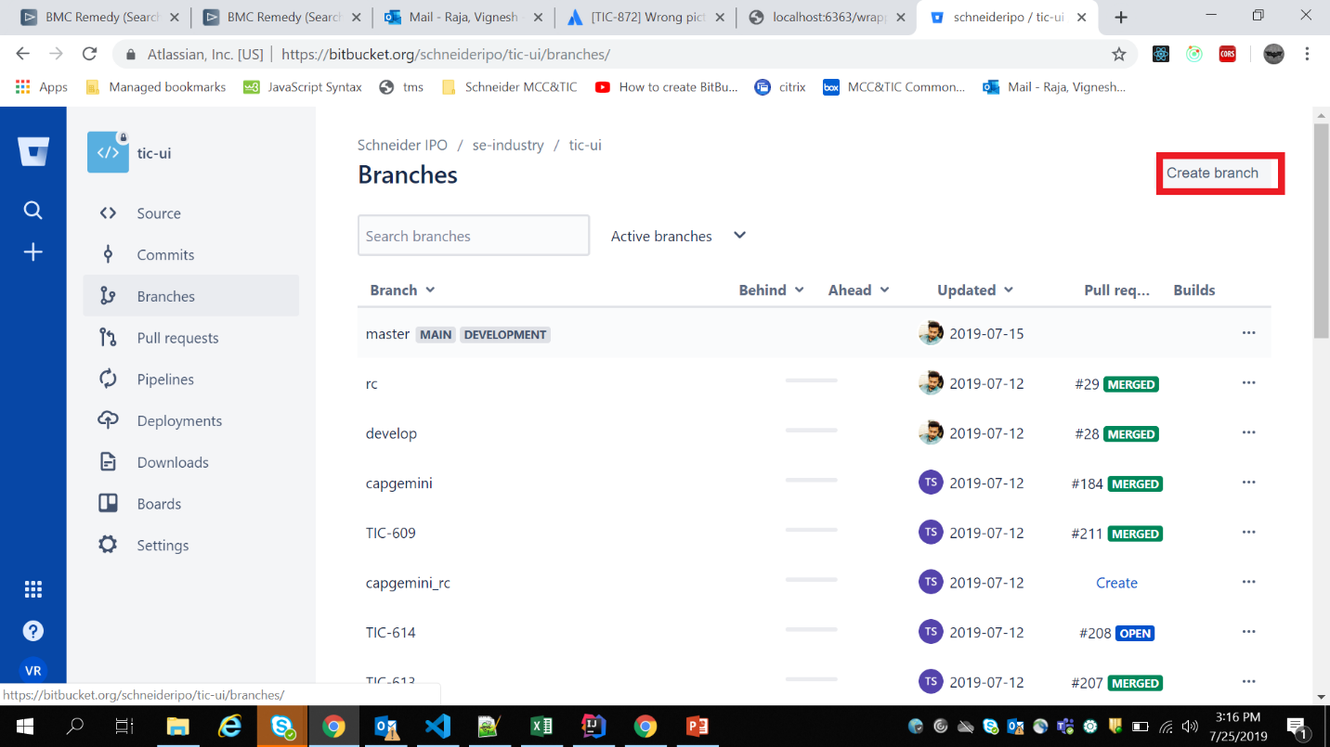

STEP 4: From develop branch   
  
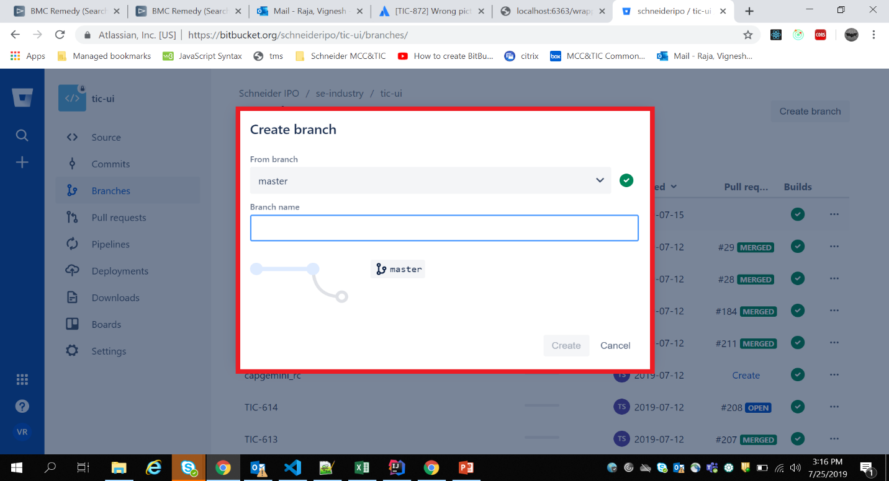

STEP 5: Refer the naming convention from top of the document.

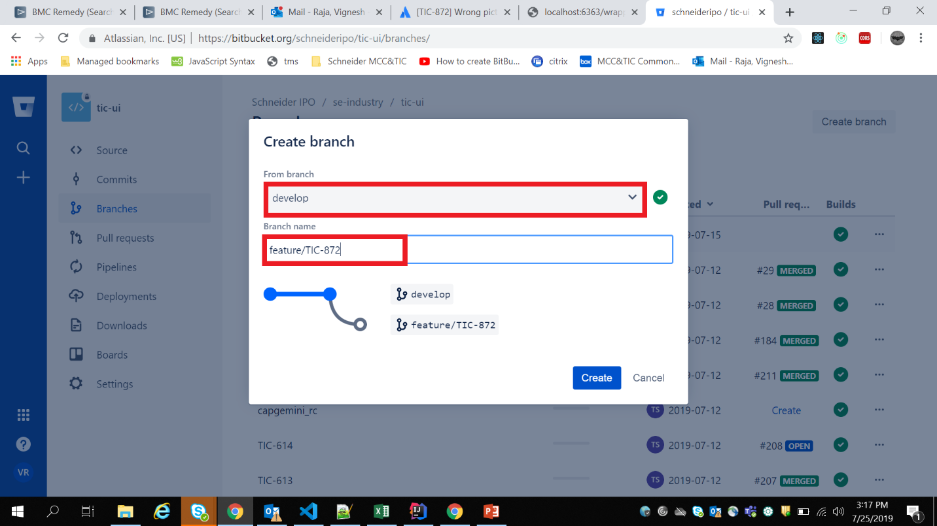  
  
STEP 6: Click on Create  
  
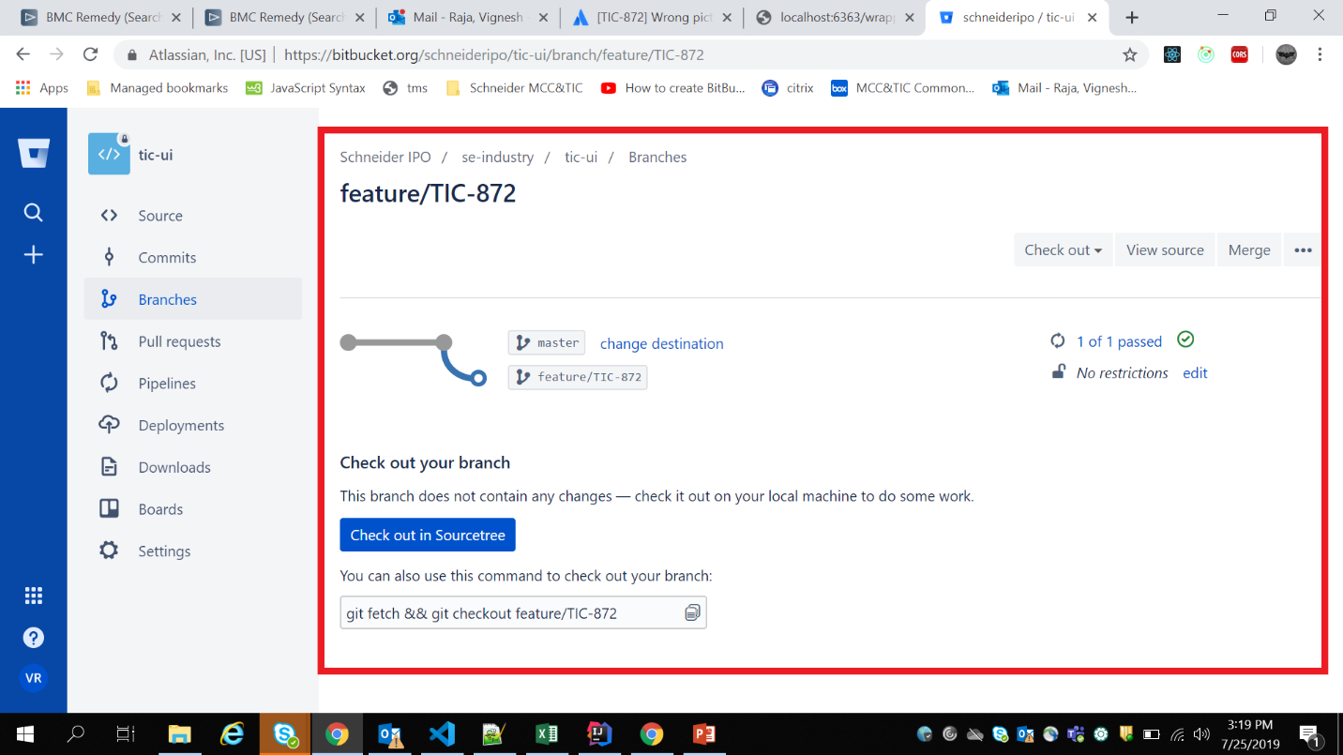

**TO PERFORM THE CODE CHANGES:**

STEP 1: Clone the Repository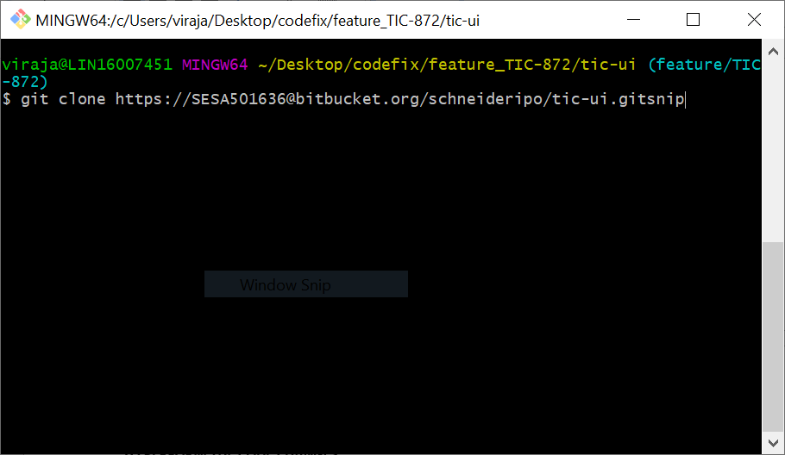

STEP 2: Move to the Created branch

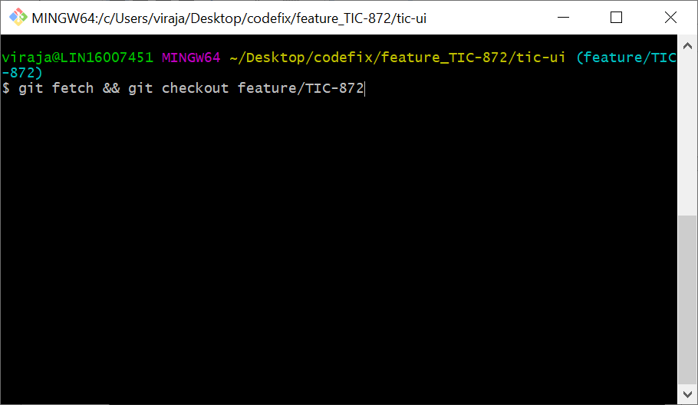STEP 3: Clone the Repository and move to the created branch

**Note: make sure that you are working in created branch**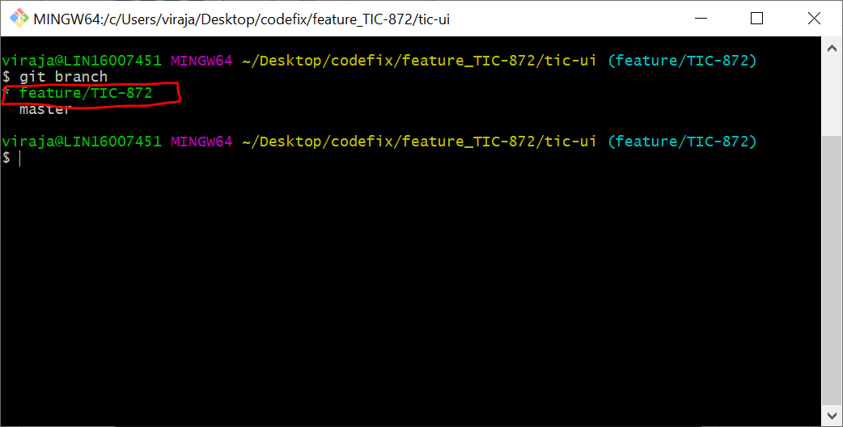

STEP 4 :Open Git gui and stage your changes.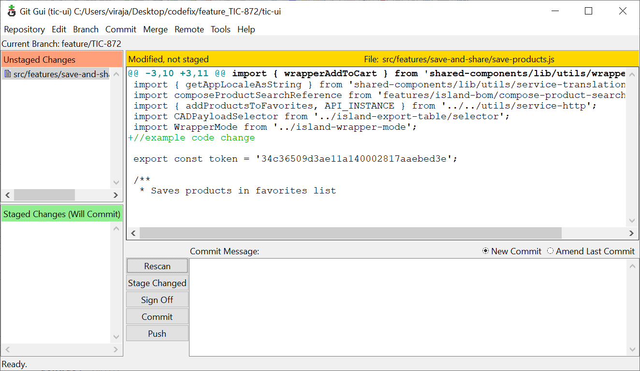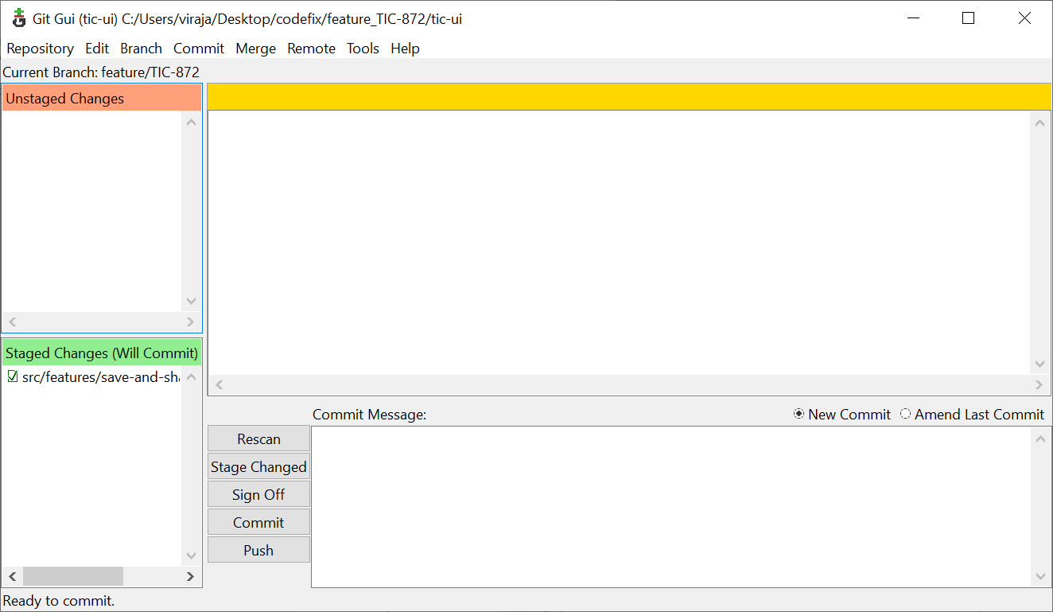

STEP 5 : Commit and push the changes .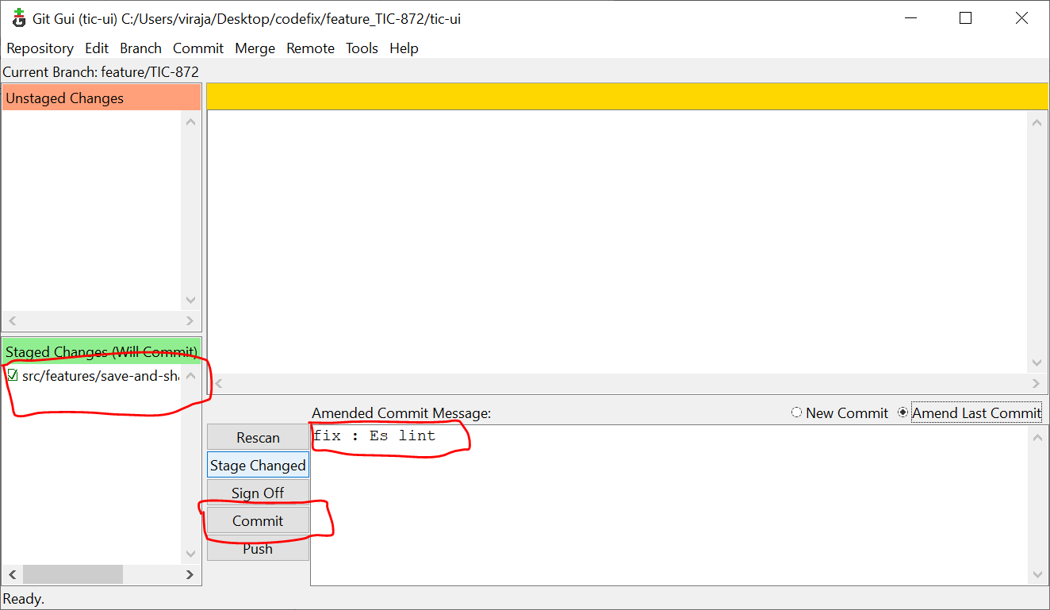

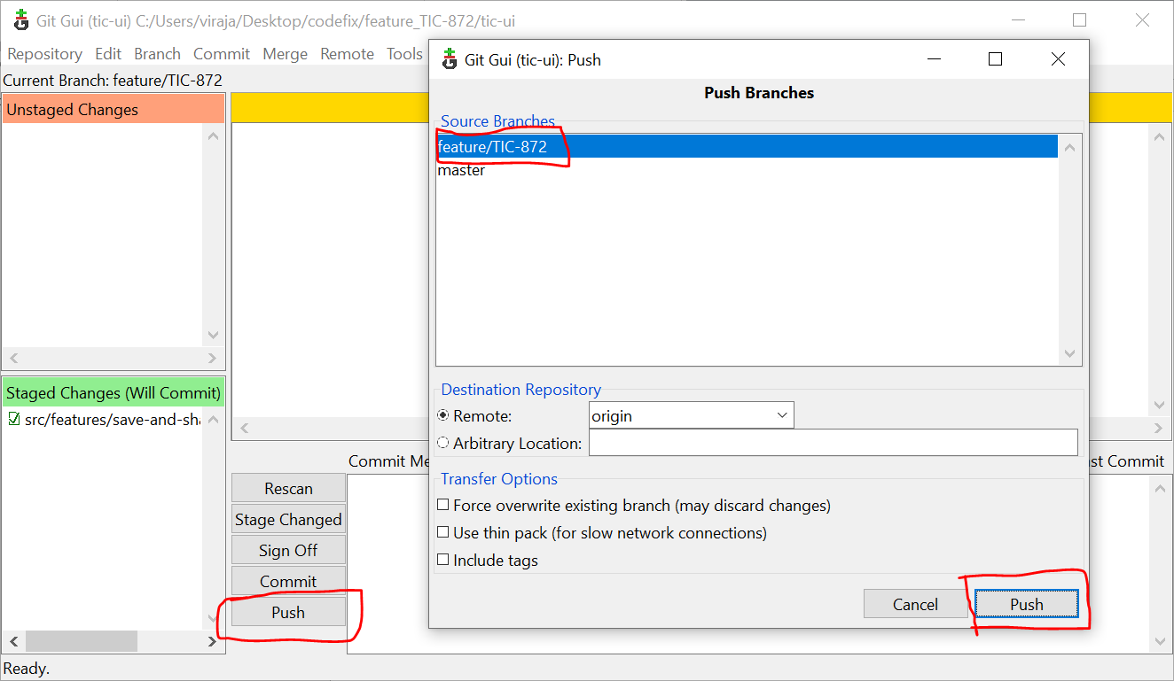

**IMP: Please check the pipeline for you committed code is successful or not. If it is successful then only we need to create pull request. Otherwise check in the pipeline what went wrong or error and fix it and again follow the above process.**

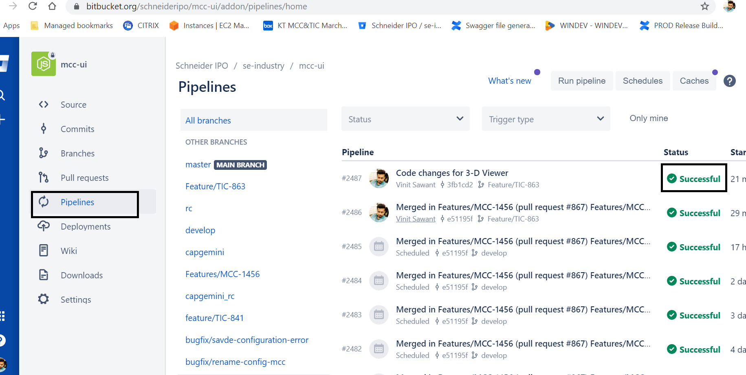

**TO CREATE PULL REQUEST:**

Create pull request and add reviewer, and submit your pull request.

Reviewer will review your pull request and merge with appropriate branch**.**